**Terrain Texture by Height Tool**

Short guide to get your stared

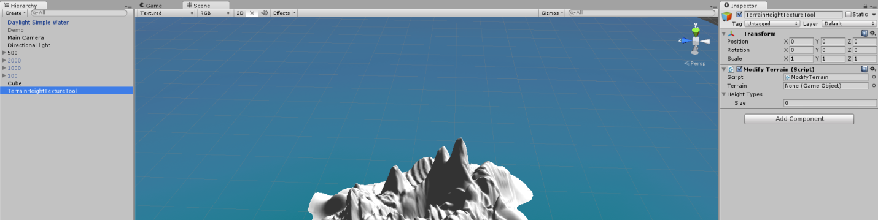

1. Make Sure you have your terrain that you want modify up and Modify Terrain script on a empty object

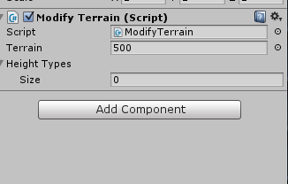

2.Drag and Drop The Terrain GameObject to Terrain field in the inspector of Modify Terrain Script

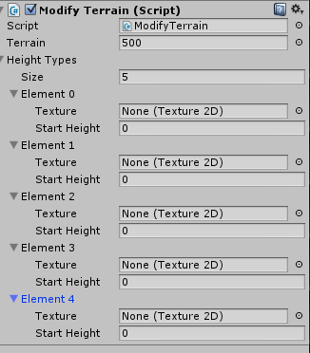

3.Pick how many texture layers you want on your terrain. Which i picked 5 as shown above

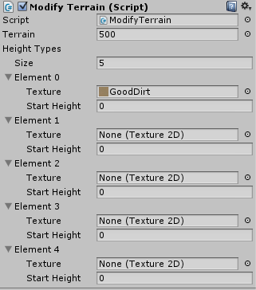

4.Now for the first layer pick the texture you want for the ground, and leave the Start Height at zero because any other number the tool will not work properly

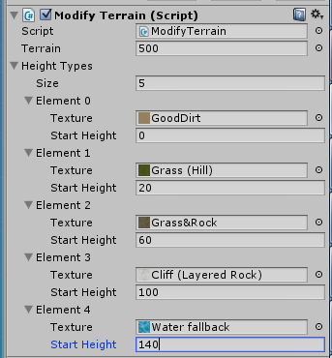

5. Now fill in the rest of the layer in just remember it must be in order for the tool to work properly from lowest to highest in my case element 0 to element 4.



6. It is time to put it to test, Click play on unity to play in game

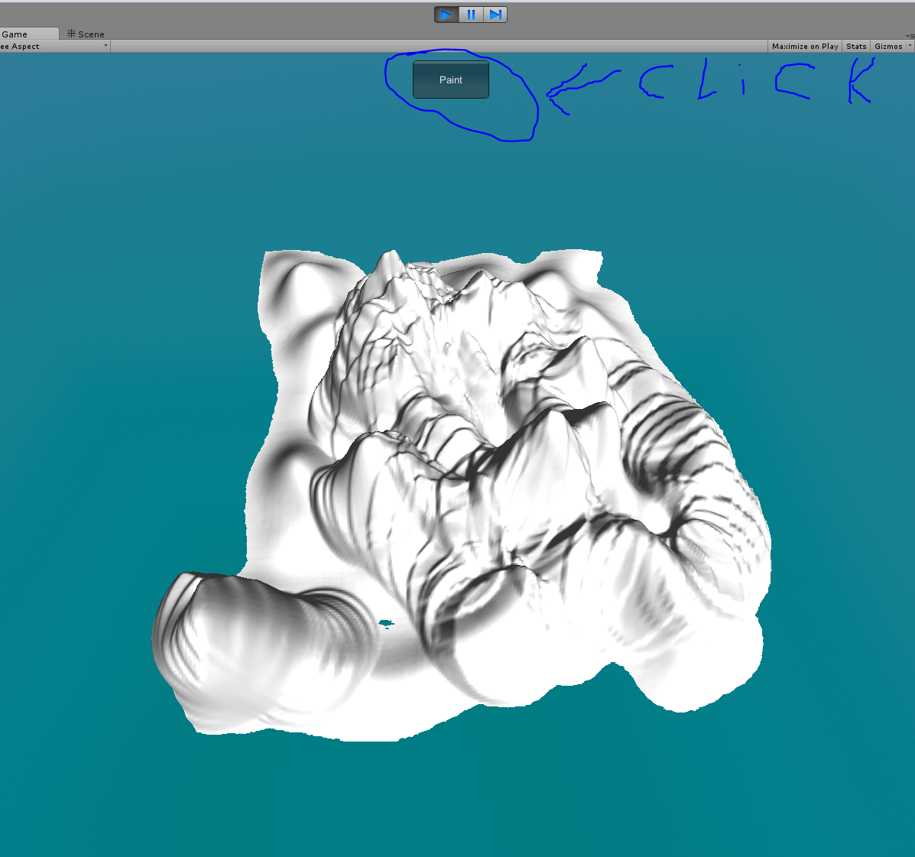

7.Click Paint

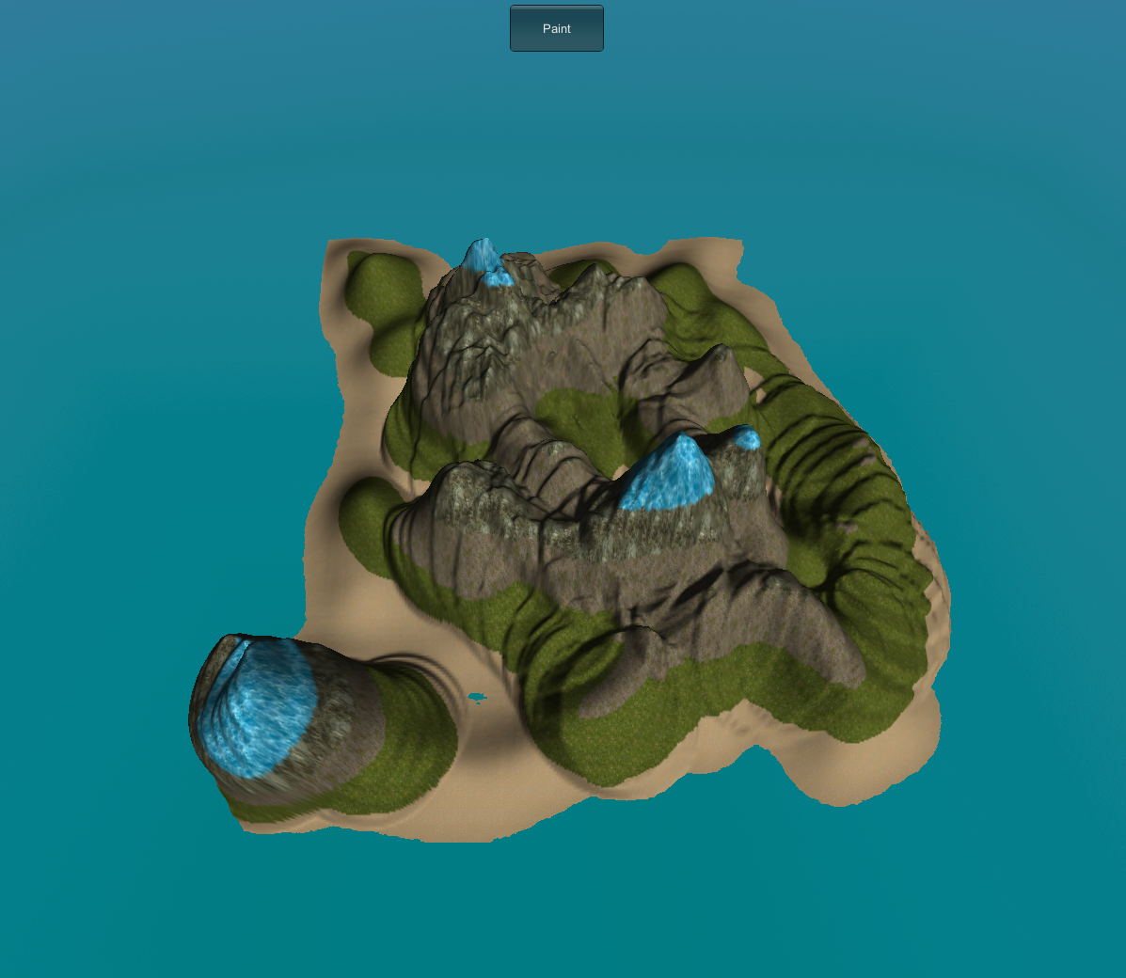

And there you GO You can modify it in runtime from the inspector and press paint to tweak it until you get results you like and when you get to something that you like just click play button to end runtime and you changes will be saved to the terrain.

***Script Reference***

Name Space:

**using TTHT;**

|  |  |
| --- | --- |
| **HeightType** | |
| **Variables** | Description |
| Texture: Texture2D | Stores the texture that you want at that height |
| StartHeight: float | Set the height on where you want it to start from |
| **Methods** | Description |
| void AddLocation(Vector2) | To add (x,z) location on the terrain that meet the height. |
| List<Vector2> GetLocations() | Returns a list of location that are stored for this height |
| void EmptyLoc() | Empties the location that are stored in that height |

|  |  |
| --- | --- |
| **TTHTS** | |
| **Variables** | Description |
| terrain: GameObject | Store the terrain that you want modified |
| HeightTypes : List<THTT.HeightType> | Stores the values that you want your terrain to go off by |
| **Methods** | Description |
| Int GetPercantageDone() | Returns the modified progress completion of the terrain |
| bool StartPaint() | Return false until the paint process is done |